XXX - I Low Pressure Paintball Marker

The XXX - I Paintball Marker is a newly designed by Target. For the last 3 years we have been developed and designed the function to get the best performance you can get from the Paintball marker.
With many patents and the revolutionary design already a step ahead from other USA top brand marker also with its metal aesthetics looks the XXX - I Paintball marker will be your best choice to distribute and OEM.

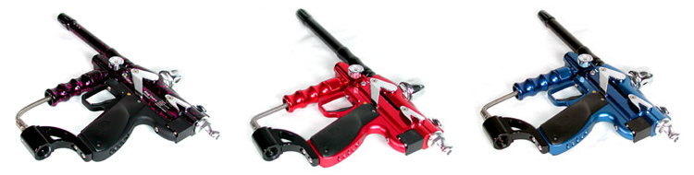

SPECIFICATION ------------------------------------------------------------------------------------------------
Caliber: | .68 inch
Working Pressure: | 200 psi
Max Shooting Speed: | 20 rounds/sec
Double Trigger: | Ergonomics design shoots faster when in semi-auto mode
12 inch Barrel: | Deal with high density internal diameter. Concentricity within range of 0.01 mm
Feed Port: | Customs to all types of loaders, No loader elbow needed
Paintball Detector: | Precise metal processing, electroplate also is the fixer for receiver body
Decompresser: | Patent Decompress Valve, allowing air to flow faster and more stable
Spurt Bolt: | Patent Bolt, Control by low pressure air system, Easy to maintain, Close Bolt percussion shooting style. When the ball push to barrel then spurt to shoot the balls out. Improve marker accuracy and saving air capacity.
Velocity Adjuster: | Can adjust the capacity when spurting the air to change the velocity also still functional when velocity adjusted to 0.
Fast Dismounter: | Within 2 second to dismount the spurt bolt, easy to maintain.
Safety Pin: | When turn off safety pin also turn off the power, when turn on the safety pin will be ready to shoot. Improved function and saver design
Charger: | Built with stable charging pressure monitor system, last the battery life (Every charged DV9V battery can be shots up to 10,000 round) also able to fits in the car charger.
LED Grip Setting: | - Semi-Auto, 2 - 6 Burst mode, Full-Auto.  - When in Full-Auto mode can be set 4 - 20 shots/sec.  - Can set up the best performance for the capacity of venting the air when setting the velocity is being confirmed.  - Can set up the paintball detector response time when setting the shooting style is being confirmed.  - Can set up the paintball detector on/off to fits different kind of loaders.  When turn on the detector and safety Pin without any rounds in the marker. Press button 3 to test the marker.  When Turn off the detector and turn on the Safety Pin no any rounds also can test the marker.  - When turn off the safety pin (which also power off), push assistance button to test the paintball marker.
Battery Valve: | Patent battery valve, last longer, faster response, low malfunction rate
Weight: | 1.4kg (3.1 lb)
Gas Supply: | N2/ HPA
Velocity of Paintball: | 300 feet per second
Battery: | 9V NiMH Rechargeable Battery, 9V Alkaline Battery

Patent Number for XXX - I :
- US: 6.601.780
- US: 6.057.750
- TW: 208088
- CN: 587773
- AND: 03014367.1

